

Classes & CRT
By: Eng. Islam Hamdy Mohamed
Guided By: Eng. Hassan Khaled

- Snippets for the implemented code
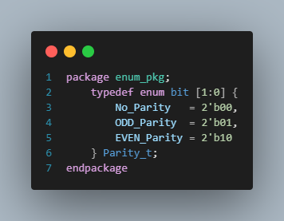

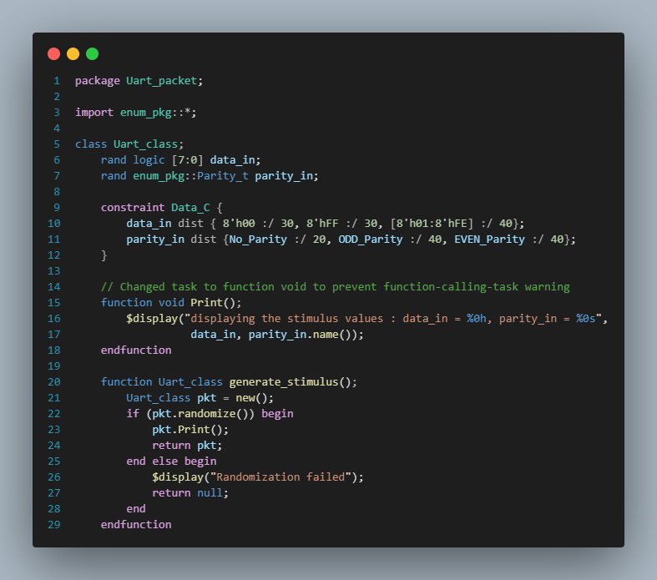
Figure 2 Uart_packet Class 1.1
Figure 1 Enum Package Definition (enum_pkg.sv)

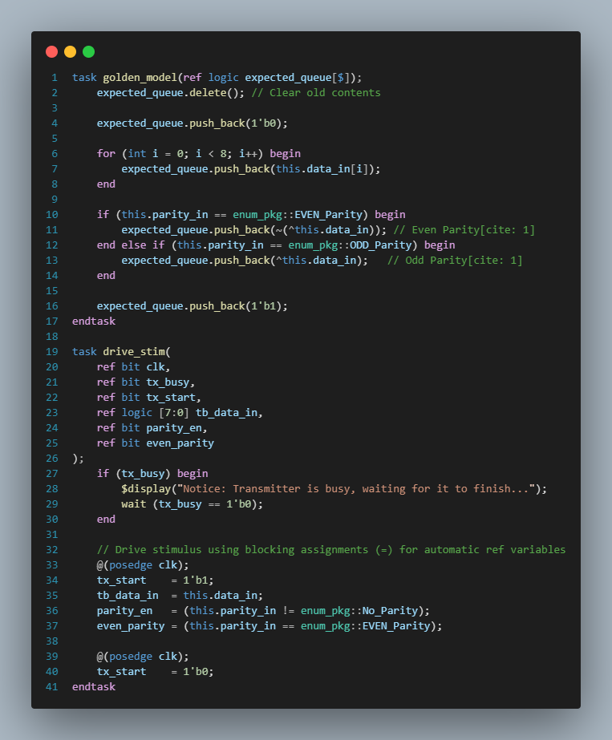

Figure 3 Uart_packet Class 1.2

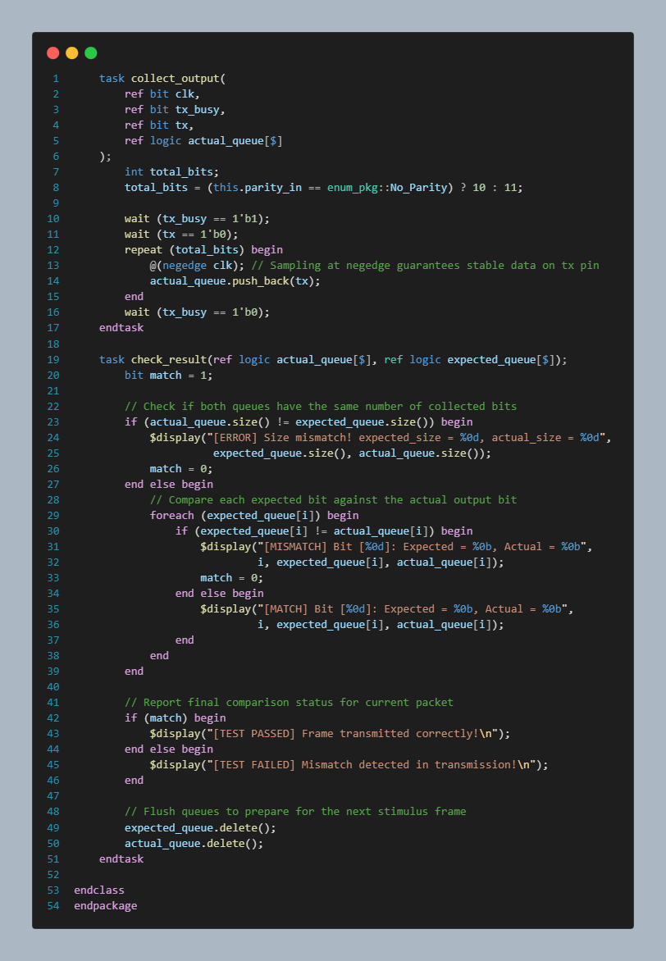

Figure 1 Uart_packet Class 1.3

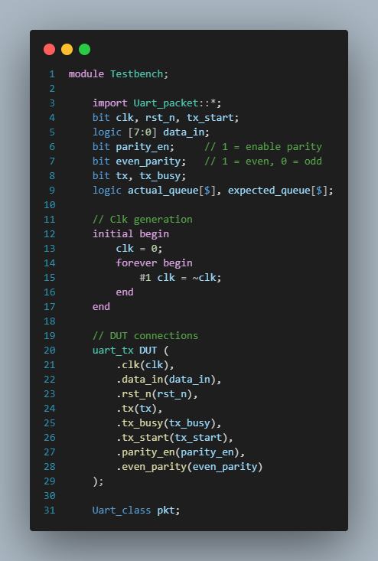

Figure 2 1.1 Top-Level Testbench Environment (Testbench.sv)

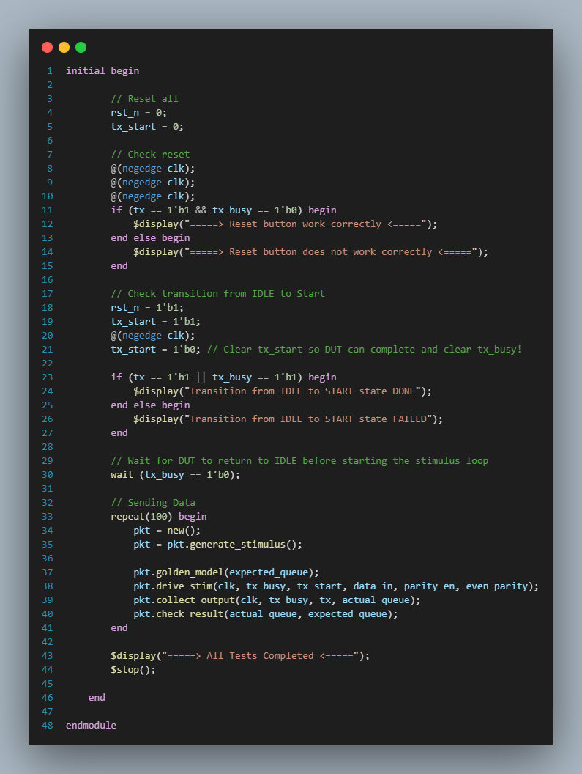

Figure 3 1.2 Top-Level Testbench Environment (Testbench.sv)
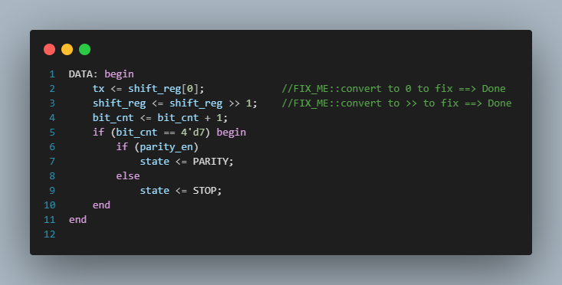

Figure 4 RTL Correction for Data Bit Order Inversion (DATA State)
- Description:
- Original Bug: The design was initially transmitting data MSB-first by driving tx <= shift_reg[7] and shifting left (shift_reg << 1), which violates the standard LSB-first UART transmission protocol.
- Applied Fix: Updated line 2 to transmit from bit 0 (tx <= shift_reg[0]) and line 3 to shift right (shift_reg <= shift_reg >> 1), ensuring correct LSB-to-MSB sequence.
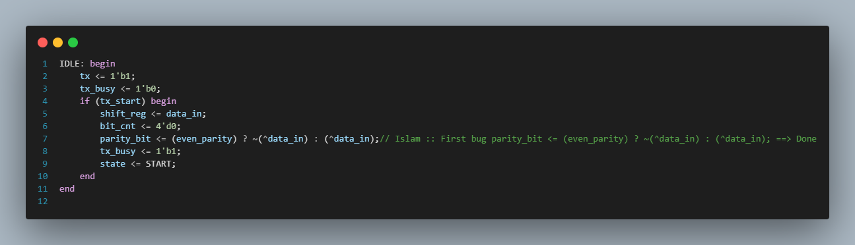
Figure 5 RTL Correction for Parity Bit Logic Inversion (IDLE State)

- Description:
- Original Bug: The conditional ternary logic inside the IDLE state inverted the parity bit calculation—generating odd parity when even_parity = 1 and even parity when even_parity = 0.
- Applied Fix: Corrected line 7 to parity_bit <= (even_parity) ? ~(^data_in) : (^data_in);, accurately generating Even parity for mode 1 and Odd parity for mode 0.

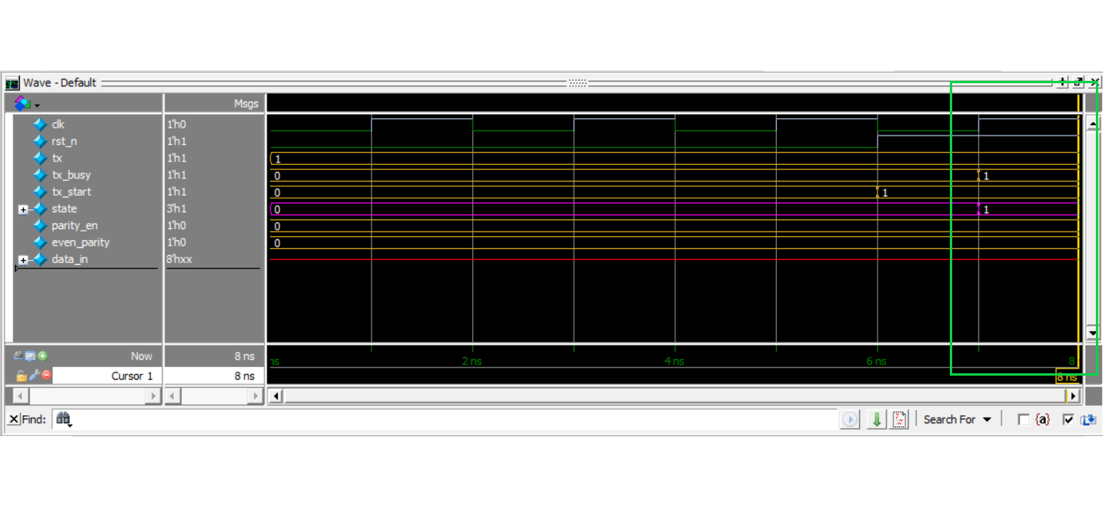
- 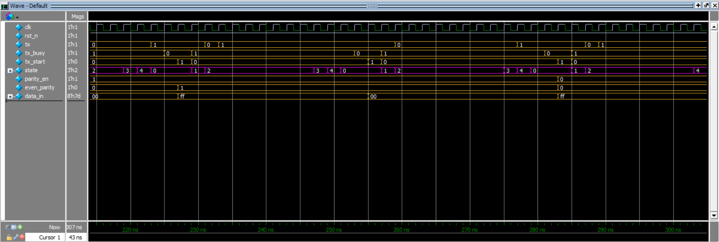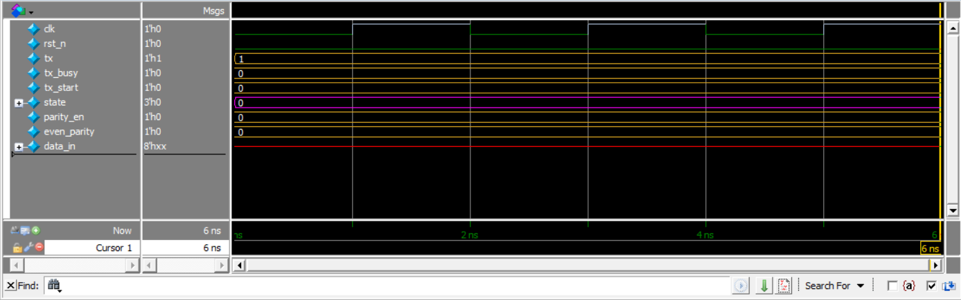Snippet for the waveform shows the different testcases
Figure 11 Waveform – Full FSM State Transitions Across Multiple Test Cases
Figure 6 Waveform – FSM Transition from IDLE to START State
Figure 9 Waveform – Reset Assertion Verification (Active-Low Reset)

- Snippets for the logs show the all printed values.
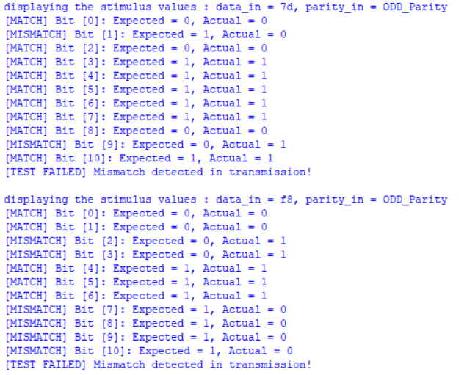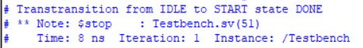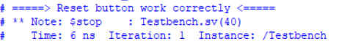
Figure 14 Log shows a missmatch in the transmission
Figure 7 Log(Transition From IDLE to Start)
Figure 12 Log(Check the reset button)

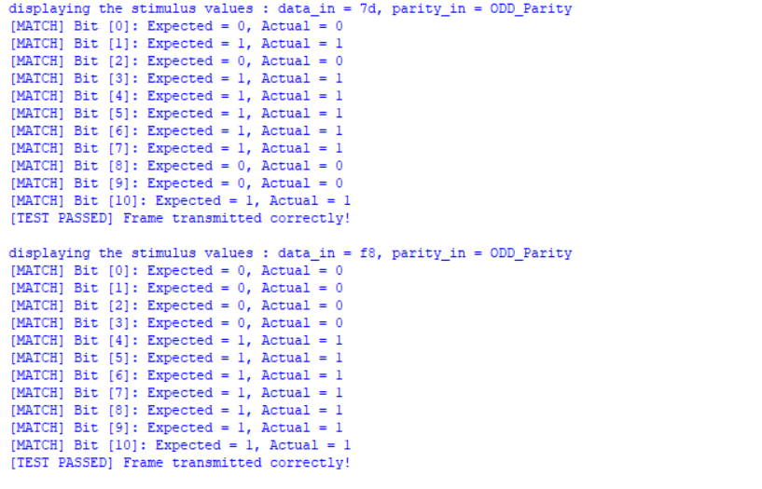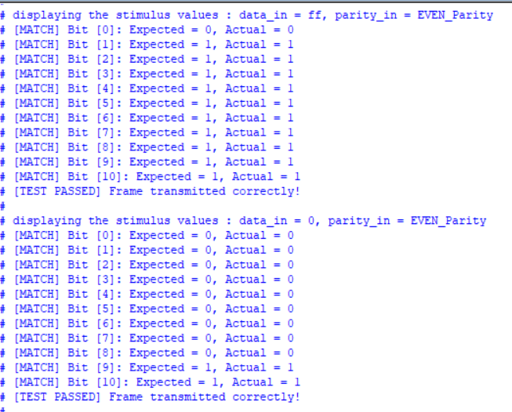
Figure 16 Log for different data with different parity bits
Figure 15 Log for testing the corners

- Snippet for Do file you have used for automating the process.
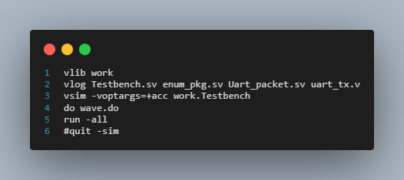
Figure 8 Do file used for automating the process

- Summary of Found Bugs & Fixes:
- Data Bit Order Inversion (MSB-First Transmission)
- Issue: The original RTL transmitted data bits MSB-first (shift_reg[7] with shift_reg << 1), violating standard LSB-first UART protocol rules.
- Resolution: Updated the DATA state logic to send LSB-first using tx <= shift_reg[0] and shift_reg <= shift_reg >> 1.
- Parity Bit Logic Inversion
- Issue: The parity generation logic was inverted in the IDLE state, producing Odd parity when Even mode was selected and vice versa.
- Resolution: Corrected the parity ternary statement to parity_bit <= (even_parity) ? ~(^data_in) : (^data_in).

